Bootcamp Challenge 1:

Module 1 Challenge Data Report

Subcategories Outcomes

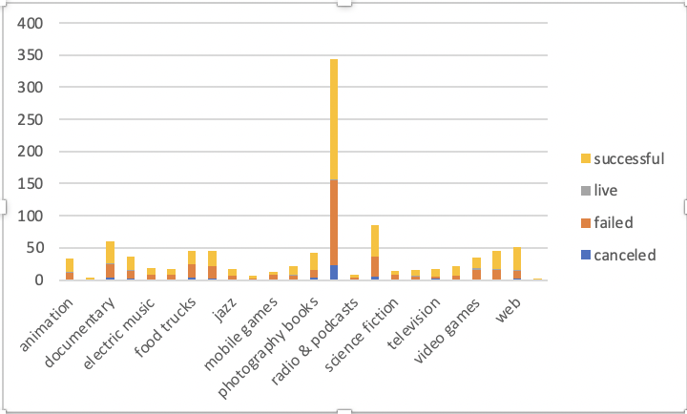

\*Note: I copied and pasted my graphs onto the work document, because when I was going towards my graphs before turning them in I was unable to see them once I moved to a new sheet, so I just wanted to include it onto the report to show that it was done

* Conclusions we can come up with based off the data are that the category with the most activity and crowd funding are theater, which has the most success, but that does not mean that proportionally it is the most successful, because you also see the most number of failures. Another conclusion you can come up with is that music can the most proportionally successful out of all the projects, and the final conclusion is that with the goals 15000-24999, and 30000-34999, which are 100% successful, they do not have too high or low of a goal which makes it more able to be successful
* Limitations of the graph include how some parts were cleaned because it included some missing parts which skew the data slightly, as well as focusing on crowdfunding for many countries because they way money conversion and inflation works may affect the data
* Other graphs you can make are comparing the average number of donors to the outcomes to see if there are any correlations to the amount of donors with a scatter plot, as well as looking to see if the categories affected the amount of money pledged.

Bonus Analysis

* The mean is more accurate for the successful outcomes, and the median is more accurate for the failed outcomes
* There is more variability with the successful outcomes because there are far more backers in general, which would mean for each successful outcome, they have a change to have to large difference in numbers of backers.